# Network Command on Ubuntu

**Ifconfig** : Ifconfig cannot be found but can be installed. To install ifconfig type **sudo apt install net-tools**.

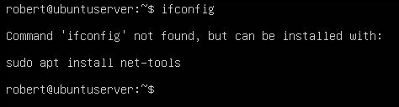

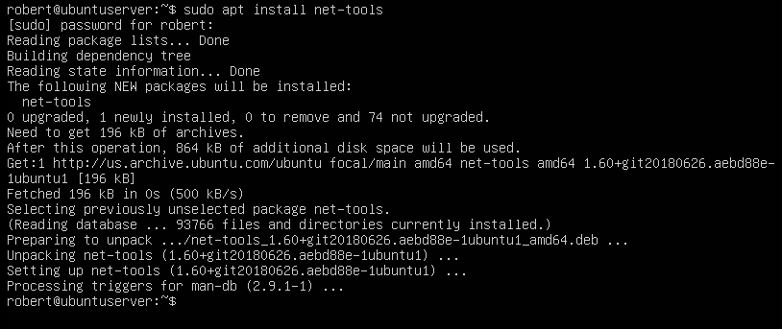

After the installation is complete, we can test the ifconfig to see if it works now

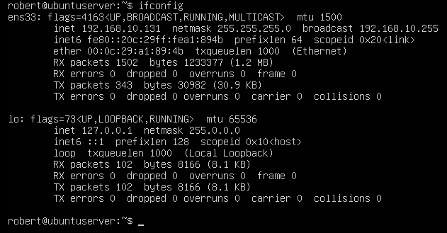

**nslookup :**

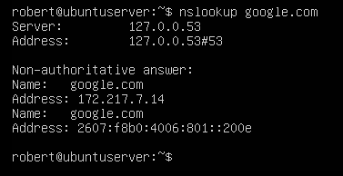

**netstat -a -n :**

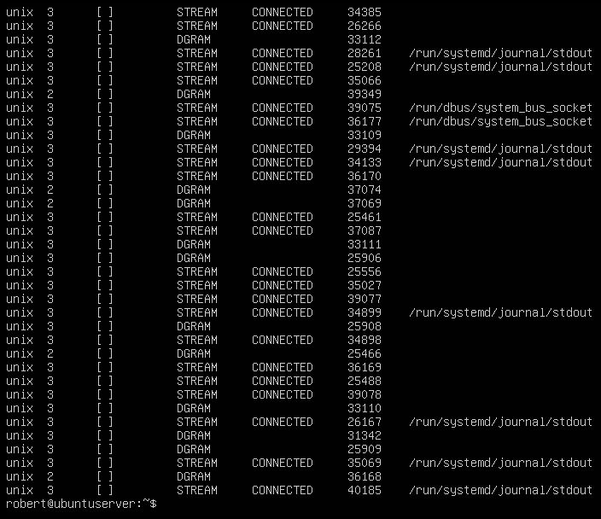

**Traceroute:** traceroute cannot be found. To install the traceroute command, we must type: **sudo install traceroute**

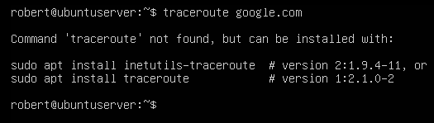

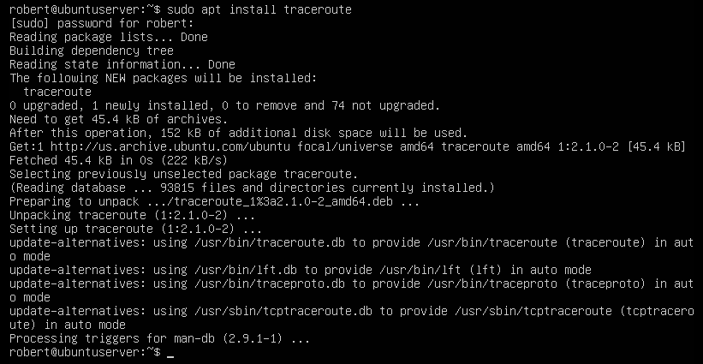after the installation is complete, we can utilize the command traceroute.

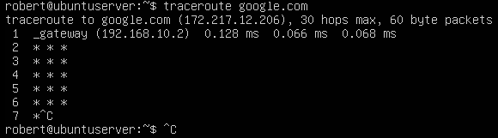

**ping:**

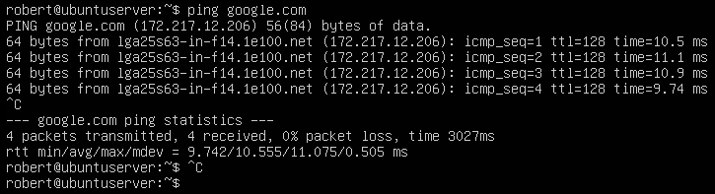

**sudo tcpdump:**

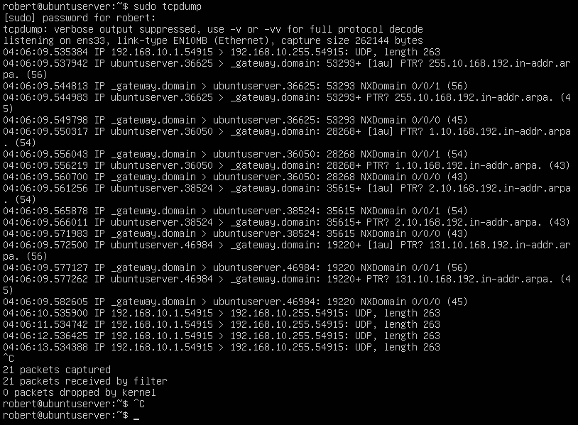

Script to Dump Network File

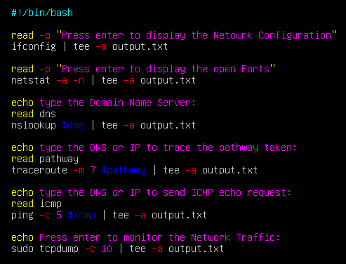

**Conclusion:** As we can see the same commands that we just did on CentOS works on Ubuntu. The only differences are that some commands on Ubuntu must be installed first to use it.